NAME: S. DHARANI
REG NO: 192472364
COURSE CODE: DSA0401
NUMPY / PANDAS ANALYSIS – QUESTIONS AND ANSWERS
QUESTION 9: REAL ESTATE PROPERTY ANALYSIS
AIM:
To calculate average listing price by location, count properties with more than four bedrooms, and identify the property with the largest area.
ALGORITHM:
1. Import Pandas.
2. Create the property DataFrame.
3. Group by location and calculate mean price.
4. Filter properties with more than four bedrooms.
5. Find the row with the maximum area.
CODE:
import pandas as pd
property_data = pd.DataFrame({
"Property_ID": [101, 102, 103, 104],
"Location": ["Chennai", "Hyderabad", "Chennai", "Bangalore"],
"Bedrooms": [3, 5, 4, 6],
"Area": [1200, 2000, 1500, 2500],
"Price": [6000000, 9000000, 7500000, 11000000]
})
print("Average price by location:")
print(property_data.groupby("Location")["Price"].mean())
print("Properties with more than 4 bedrooms:",
len(property_data[property_data["Bedrooms"] > 4]))
print("Largest property:")
print(property_data.loc[property_data["Area"].idxmax()])
INPUT:
Four sample property records.
OUTPUT:
Average price: Bangalore = 11000000, Chennai = 6750000, Hyderabad = 9000000
Properties with more than 4 bedrooms: 2
Largest property: Property_ID 104, Area 2500
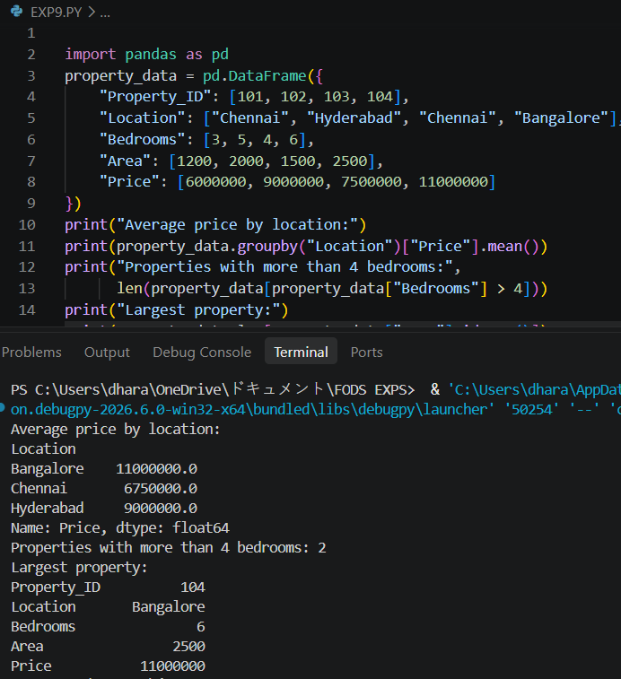
RESULT: Property prices, bedroom count and largest area were analyzed successfully.

